- Purpose
This procedure provides policy and procedure for software design and development.

- Scope
This procedure applies to the design and development of:
- Software used as a component, part, or accessory of a medical device;
- Software that is itself a medical device :
- Software used in the production of a device (e.g., programmable logic controllers in manufacturing equipment); and
- Software used in implementation of the device manufacturer’s quality system (e.g., software that records and maintains the device history record).

This procedure is intended to be followed by all EPIC personnel who are involved with software design and development.

- Definitions
Design Validation | Establishing by objective evidence that device specifications conform to user needs and intended uses.
EPIC ClearView | The core software product that drives the EPIC system.
Non-Breaking Change | A change to the software that is purely cosmetic, not affecting any of the business or calculation logic.
Process Validation | Establishing by objective evidence that a process consistently produces a result or product meeting its predetermined specifications.
Requirements | The needs or expectations for a system and/or its software. There can be many different kinds of requirements (e.g., design, functional, implementation, interface, performance or physical requirements).
Specification | In software development, a specification is defined as a document that states the requirements
Verification | Confirmation by examination and provision of objective evidence that specified requirements have been fulfilled.
Validation | Confirmation by examination and provision of objective evidence that the particular requirements for a specific intended use can be consistently fulfilled. Also said as, confirmation by examination and provision of objective evidence that software specifications conform to use needs and intended uses, and that the particular requirements implemented through software can be consistently fulfilled.

- Responsibilities
User | - Complies with the policy and procedure for all new or revised design projects.  - Ensures the most current version of this document is used when referenced.  - Acts as project coordinator to ensure proper protocol development, accurate and timely protocol execution, and development of the final report.
Departmental Management | - Ensures departmental personnel are properly trained before using this policy or procedure.  - Assigning personnel as project manager and/or to validation team(s).  - Complies with the policy and procedure for all new or revised design projects.  - Ensures the most current version of this document is used when referenced.  - Reviews and approves protocols prior to validation and summary report of the validation activities to ensure that activities reflect actual activities performed, at a minimum.
Quality Assurance | - Complies and enforces the document control standards within this document.  - Monitors the implementation and effectiveness of this document.  - Conducts periodic audits to assure compliance.  - Reviews and approves protocols prior to validation and summary report of the validation activities to ensure that all quality system requirements are met, at a minimum.
Engineering/Manufacturing | - Provides technical and specific guidance for protocol development and validation process execution.  - Reviews and approves protocols prior to validation and summary report of the validation activities to ensure that summary report meets the technical requirements for software validation and that conclusions drawn are valid, at a minimum.

- Policy
Software development is required to follow the appropriate design control processes. This document is intended to provide guidance and requirements specific to software development only.

- Procedure
NOTE: Based on the lack of complexity of the proposed design projects, some basic design control steps may be combined unless otherwise specified below.

  - Project Initiation- Development of the software requirements specification (Design Inputs) and the project Design and Development Plan (DDP)
    - New software development begins with identifying the need and generating requirements. Once the high level requirements have been established, a DDP will be developed to provide a general outline of the design project.
      - The Software Requirements Specification may be documented using the Requirements Template (ITF-002) or the Input/Output Matrix (EGF-002).
      - Software requirements are intended to be updated during the development process.
    - The design project is initiated by performing a design review of the requirements and DDP. The approval is documented on a Design Approval Form. This design review will include at least one member of executive management.
      - If the project is not approved, document the reason for rejection and any follow up action items. The requirements document and DDP will be filed with the Design Approval Form.
      - If the project is approved, the original approved documents are stored with the Design Approval Form in a newly created project design history file.
    - The project manager uses the approved requirements and DDP to create a detailed project plan including resources needed to develop the software in compliance with EPIC’s design control procedures and all regulatory requirements. Once completed, this detailed project plan will then be formally reviewed by the design team. This design review will be documented using the Design Review Minutes Form.

  - Software Architecture Development (Design)- Development of the risk analysis documents and software specifications
    - Software Risk Analysis-
      - The project manager will work with the design team to develop the risk analysis according to the process outlined in the Risk Management procedure.
      - Risk analysis documents are intended to be updated during the development process.
      - Once completed, the risk analysis documentation will then be formally reviewed by the design team. This design review will be documented using the Design Review Minutes Form.
    - Software Input/Output Matrix
      - The project manager will work with the design team to develop the Input/Output Matrix.
      - This matrix may have been initially generated as a part of the project initiation development of the requirements. The Input/Output Matrix is intended to collate all design requirements, specifications and verification and validation activities.
      - The Input/Output Matrix is intended to be a living document which is updated based on the software development stage. The Input/Output Matrix will document the requirements and specifications and be reviewed and approved by the Design Team prior to software construction. Verification and validation activities will be documented when completed later in the design process.
    - Software Specifications (Design Outputs)
      - The Software Specifications may be documented using the Specifications Template (ITF-003) or the Input/Output Matrix (EGF-002).
      - Software specifications are intended to be updated during the development process.
    - The software risk analysis documents, Input/Output Matrix, and specifications (if applicable) will be approved prior to software construction.

  - Software Construction- Development of the software code
Source code control. All required source files for the application are stored in a Source Code Control System (SCCS) called Perforce. Perforce is an internationally recognized company and is used by many of the largest companies in the world such as:
- Electronic Arts
- Cisco Systems
- MCI
- GE Healthcare

Perforce is secured by ID/Password authentication, if you do not have the valid credentials, check with EPIC IT. All source code should be synchronized to the local development machine before changes to the code begin.
Unless specifically identified in the DDP, software should be developed in Visual Studio using C# as the development language. All best practice coding standards should be followed including those outlined in EPIC’s General Coding Standards procedure.
Unit testing – All software developers should be unit testing their changes locally as is appropriate. It is imperative that only fully unit tested changes be committed to the SCCS system. Some unit testing may be executed as a part of code development which is not documented. However, all software development will ultimately have documented unit testing for each software specification performed and documented according to the process outlined in the Software Development Verification Testing Procedure.
Design Walk-through- A walk through of the entire software will be conducted to ensure that the output of software construction meets the user expectations may be performed. If the expectations are not met, the developer will work with clinical, executive management and marketing staff to establish new requirements and specifications as appropriate. The appropriate documentation will be updated to reflect the new understanding of the requirements and specifications and software construction will resume ensuring the final software meets all requirements and specifications.
Check in – Once the code is complete and it has been satisfactorily unit tested, it can be checked back into the SCCS. During check in, a description of the change must be entered. The description should include the following:
- A description of the code change that was made (short and simple, but complete).

This check in process will identify the beginning of revision control on the software. In order to fully track revision history, a Revision History table may be generated which contains at a minimum the Version Number, Date Established (i.e., date checked into SCCS) and Description of Changes made to the database. This record will be updated for version changes during verification and validation activities.
Software development documentation- The developer and/or project manager will coordinate the development of key regulatory documentation as required. The following are documents that may be generated to provide information available for regulatory purposes:
      - Software description- A summary overview of the features and software operating environment. This document may also include a statement regarding the FDA’s Level of Concern and a description of the rational for the level selected (reference FDA’s Guidance for the content of Premarket Submissions for Software Contained in Medical Devices).
      - Architecture Design Chart- A detailed description of the functional units and software modules. This chart may include state diagrams as well as flow charts.
      - Software Development Environment Description- A summary of the software life cycle development plan including a summary of the configuration management and maintenance activities.
      - Code Reviews- Upon the completion of all software construction activities, an independent, properly trained individual will perform a code review to ensure that software construction was conducted according to EPIC’s software development SOPs like Software Design and General Coding Standards.

  - Software Validation- Development of the objective evidence that the software developed conforms to the user needs and intended uses established in the design documentation.
    - All validation testing of completed software development (imitated as changes and new product development) will be conducted and documented according to the requirements specified in the Software Validation SOP.
    - Software changes and/or new development are not released until all quality system requirements are met. The following basic steps are conducted as a part of validation testing:
      - Develop, review and approve the software verification and validation plan.
      - Develop, review and approve test protocols according to the verification and validation plan.
      - Execute test protocols
      - Summarize test results, review and approve final report- Include a summary of all unresolved anomalies.
  - Software Design Review and Approval
    - Perform a design review of all design documentation. The Software Development Checklist may be used, but is not required.
    - Participants- the design review team will include representatives of all functions concerned with the release of the software and that at least one individual who does not have direct responsibility for the design stage being reviewed. Specialists will also be included in the design review to ensure that participants include those with the technical knowledge to evaluate the design documentation and final product configuration.
    - The final review and approval design review will include the following activities:
      - A systematic assessment of the design results including software design and user validation assessments;
      - An assessment of the existing or emerging problems with design (e.g., unresolved anomalies, etc.);
      - An assessment of the accuracy and completeness of all design documentation; and/or
      - Confirmation that the software is ready to move to the next stage of development/use.
      - An assessment of all outstanding project action items with justification for any remaining outstanding project action items.
    - Design approval or rejection will be documented on the Design Approval Form. Meeting minutes and action items will be recorded on a Design Review Minutes Form.
    - All approved design documentation will be filed in the software project design history file.
  - Approved Software- IT will follow all applicable quality system procedures for the release of any approved software.

- Design Changes
After the initial release, software design may be modified to accommodate changes based on regulatory requirements, user input, etc.

  - Design changes may result from different inputs such as clinical study results, user feedback (e.g., complaint handling), regulatory requirements, etc. When changes are proposed, the inputs are assessed and the software requirements specification will be red-lined to reflect the proposed changes. The changes are then summarized on a Design Change Summary Form.
  - The project manager will develop a basic implement plan which outlines which portions of the software development process which will be required to implement the changes. Depending upon the complexity of the proposed changes, all or only part of the design development process may be required. A written justification for exclusion of any steps will be included in the implementation plan. The implementation plan will be included with the Design Change Summary From.
  - Perform a design review of the Design Change Summary Form.
    - Participants- the design review team will include representatives of all functions concerned with the proposed software changes and that at least one individual who does not have direct responsibility for the design stage being reviewed.
    - Approval of the proposed changes and design plan will be recorded in the space provided on the Design Change Summary Form.
  - The design project is managed by the project manager according to the approved implementation plan will appropriate design reviews as specified in the implementation plan.

- Reference
EG-011, Software Validation
EG-016, Software Development Verification Testing Procedure
EGF-001, Design Approval Form
EGF-002, Design Input and Output Matrix
EGF-003, Design Review Minutes Form
EGF-012, Design and Development Plan Template
IT-002, Software Release
IT-004, Software Design Guidance
IT-007, General Coding Standards
ITF-002, Requirements Template
ITF-003, Specifications Template
ITF-005, Software Development Checklist
ITF-010, Design Change Summary Form
Guidance for the Content of Premarket Submissions for Software Contained in Medical Devices

- Attachments
Attachment A, Medical Device Software Development Process Flow

Attachment A
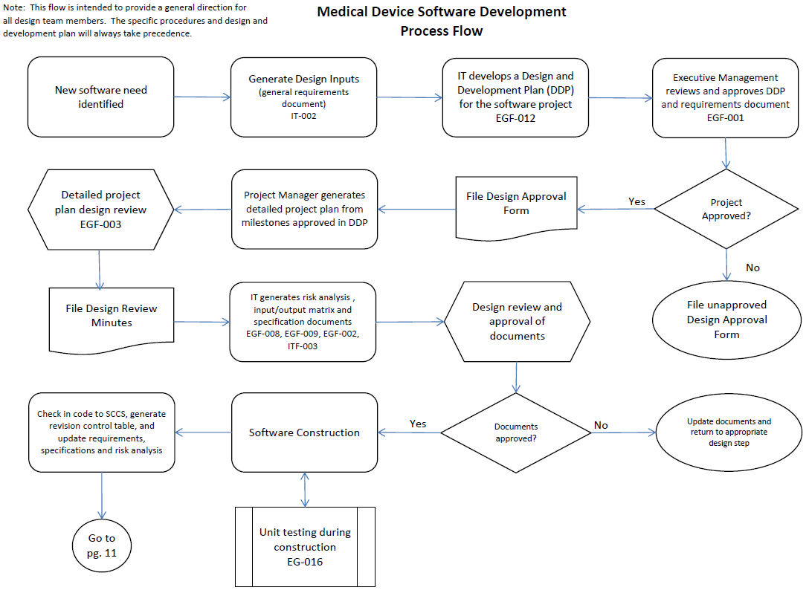
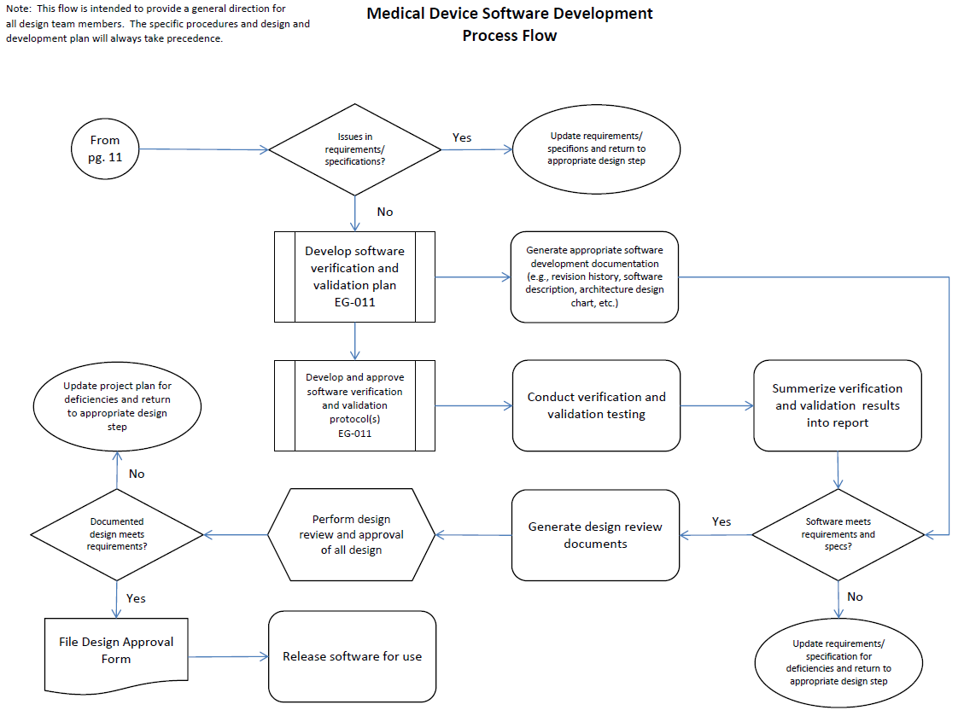
Document Revision History
Change Order Number: | Version Number: | Description of Change: | Date: | Updated by:
CC-011810-01 | 000 | New Document | 1/26/10 | AFM
CC-120202-01 | 001 | Update section 6.3.4 to refer to the Software Development Verification testing Procedure. | 2/3/12 | A. Mason
CC-120208-01 | 002 | Add 21 CFR Part 11 to the reference documents. | 2/28/12 | A. Mason
CC-120328-01 | 003 | Updated entire procedure to reflect current design development process. Add a process flowchart as Attachment A. | 5/14/12 | A. Mason
CC-130319-02 | Obs | Obsolete Document | 3/21/13 | L. Kurth

